**Data Structures & Algorithm LAB**

**LAB # 01**



**Spring 2020**

**CSE-210L Data Structures & Algorithms**

Submitted by

**Shah Raza 18PWCSE1658**

**Muhammad Hassan 18PWCSE1669**

**Razi Ullah Durrani 18PWCSE1673**

**Muhammad Adil Khan 18PWCSE1683**

“On my honor, as student of University of Engineering and Technology, I have neither given nor received unauthorized assistance on this academic work.”

Student Signature: ______________

Submitted to:

**Dr. Khurram S. Khattak**

Day, Date (Tuesday, March 3rd, 2020)

**Department of Computer Systems Engineering**

**University of Engineering and Technology, Peshawar**

**Task 1:**

Write a program that reads numbers from the user in to an array of type “float”, average them and print the result.

**Code:**

#include <iostream>

using namespace std;

double Avg(int *ptr, int s)

{

double avg=0;

double sum=0;

for(int i=0;i<s;i++)

sum+=*(ptr+i);

avg=sum/s;

return avg;

}

int main()

{

int SIZE;

int *Array;

cout<<"Enter the length of the Array: ";

cin>>SIZE;

Array = new int[SIZE];

cout<<"Enter the Elements of the Array: ";

for(int i=0;i<SIZE;i++)

cin>>*(Array+i);

double res= Avg(Array,SIZE);

cout<<"Average of the Array: "<<res;

delete[] Array;

return 0;

}

**Output:**

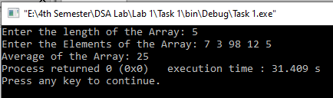

**Task 2:**

Write a function that takes an int array and array’s size as argument and return maximum value of array elements.

**Code:**

#include <iostream>

using namespace std;

int maxValue(int arr[],int SIZE)

{

int temp = arr[0];

for(int i=1;i<SIZE;i++)

{

if(arr[i]>temp)

temp = arr[i];

}

return temp;

}

int main()

{

int SIZE;

cout<<"Enter the Size of Array: ";

cin>>SIZE;

int Array[SIZE];

cout<<"Enter the Elements of Array: ";

for(int i=0;i<SIZE;i++)

cin>>Array[i];

int res = maxValue(Array,SIZE);

cout<<"Max element of the Array is: "<<res;

return 0;

}

**Output:**

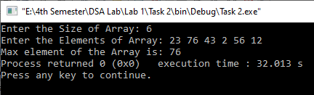

**Task 3:**

Write a function that takes an int array and the array's size as arguments. It should create a new array that is twice the size of the argument array. The function should copy the contents of the argument array to the new array, and initialize the unused elements of new array with -1. The function should return a pointer to the new array.

**Code:**

#include <iostream>

using namespace std;

int *NewArray(int arr[],int SIZE)

{

int *ptr;

ptr = new int[SIZE*2];

int i=0;

for(;i<SIZE;i++)

*(ptr+i)=arr[i];

for(;i<SIZE*2;i++)

*(ptr+i)=-1;

return ptr;

}

int main()

{

int SIZE;

cout<<"Enter the Size of Array: ";

cin>>SIZE;

int Array[SIZE];

cout<<"Enter the Elements of Array: ";

for(int i=0;i<SIZE;i++)

cin>>Array[i];

int *ptr = NewArray(Array,SIZE);

cout<<"New Array: ";

for(int i=0;i<SIZE*2;i++)

cout<<*(ptr+i)<<" ";

delete[] ptr;

return 0;

}

**Output:**

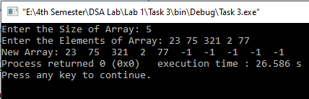

**Task 4:**

Write a function that takes two int arrays and the arrays' sizes as arguments. It should create a new array big enough to store both arrays. Then it should copy the contents of the first array to the new array, and then copy the contents of the second array to the new array in the remaining elements, and return a pointer to the new array.

**Code:**

#include <iostream>

using namespace std;

int *mergeArray(int arrA[],int SIZE1, int arrB[],int SIZE2)

{

int *ptr;

ptr = new int[SIZE1+SIZE2];

int i=0;

for(;i<SIZE1;i++)

*(ptr+i)=arrA[i];

for(int a=0;a<SIZE2;a++,i++)

*(ptr+i)=arrB[a];

return ptr;

}

int main()

{

int SIZE1,SIZE2;

cout<<"Enter the Size of First Array: ";

cin>>SIZE1;

int ArrayA[SIZE1];

cout<<"Enter the Elements of Array: ";

for(int i=0;i<SIZE1;i++)

cin>>ArrayA[i];

cout<<"Enter the Size of Second Array: ";

cin>>SIZE2;

int ArrayB[SIZE2];

cout<<"Enter the Elements of Array: ";

for(int i=0;i<SIZE2;i++)

cin>>ArrayB[i];

int *ptr = mergeArray(ArrayA,SIZE1,ArrayB,SIZE2);

cout<<"New Array: ";

for(int i=0;i<SIZE1+SIZE2;i++)

cout<<*(ptr+i)<<" ";

delete[] ptr;

return 0;

}

**Output:**

